**Hands-on Documentation: Exercise 4**

**Title:**

JUnit – AAA Pattern, Test Fixtures, Setup & Teardown

**Objective:**

Use the **Arrange-Act-Assert (AAA)** testing pattern and **@Before / @After** annotations to improve test readability and modularity.

**Tools Used:**

* IntelliJ IDEA
* JUnit 4.13.2
* Java 8+
* Maven

**Steps Performed:**

**Step 1: Created MathUtils.java**

public class MathUtils {

public int multiply(int a, int b) {

return a * b;

}

public int divide(int a, int b) {

return a / b;

}

}

**Step 2: Created MathUtilsTest.java Using AAA + Setup/Teardown**

@Before

public void setUp() {

mathUtils = new MathUtils(); // Setup

}

@After

public void tearDown() {

System.out.println("Test teardown completed."); // Teardown

}

@Test

public void testMultiply() {

// Arrange

int a = 5, b = 4;

// Act

int result = mathUtils.multiply(a, b);

// Assert

assertEquals(20, result);

}

**Output: 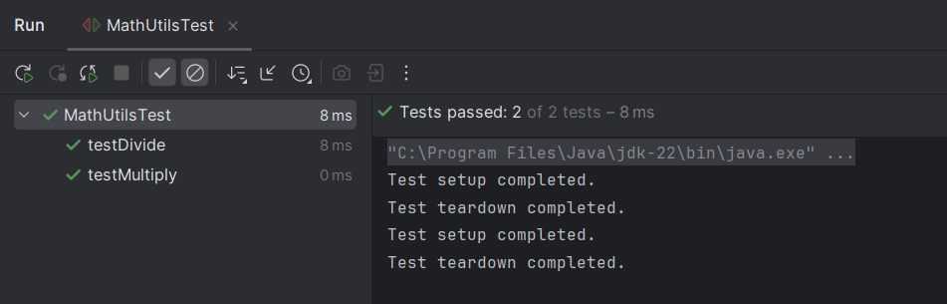 Conclusion:**

* Practiced the **AAA pattern** for clean test structure.
* Used **test fixtures** with @Before and @After.
* Improved **readability**, **modularity**, and **maintenance** of tests.